**Project 2**

**Weather Forecasting App**

**(Bachelor Of Computer Application)**

By

Arpan Dasgupta (Roll no.: 220755207992)

Tanmoy Santar (Roll no.: 220755210835)



Annex College of Management Studies

(Centre For Technical & Management Studies)

(Jan 2025)

CERTIFICATE

It is certified that the work contained in the project report titled “Smart Health Information System,” by “Arpan Das Gupta, Tanmoy Santra” have been carried out under my/our supervision and that this work has not been submitted elsewhere for a degree.

Signature of Supervisor(s)

Atikul Islam

CSE

Annex College of Management Studies

Jan 2025

Declaration

I/We declare that this written submission represents my/our ideas in my/our own words and where others' ideas or words have been included, I /We have adequately cited and referenced the original sources. I/We also declare that I/We have adhered to all principles of academic honesty and integrity and have not misrepresented or fabricated or falsified any idea/data/fact/source in my submission. I/We understand that any violation of the above will be cause for disciplinary action by the Institute and can also evoke penal action from the sources which have thus not been properly cited or from whom proper permission has not been taken when needed.

Arpan Dasgupta

Roll No: 220755207992

Date:

Tanmoy Santra

Roll No: 220755210835

Date:

Approval Sheet

This project report entitled (Weather Forecasting App) by (Alex Johnson) is approved for the project 2.

Examiners Date:

Place:

Supervisor (s)

PRINCIPAL

___________________

________

##### ACKNOWLEDGEMENT

It gives us great pleasure to find an opportunity to express our deep and sincere gratitude to our project guide Atikul Islam. We do very respectfully recollect his constant encouragement, kind attention and keen interest throughout the course of our work. We are highly indebted to him for the way he modelled and structured our work with his valuable tips and suggestions that he accorded to us in every aspect of our work.

We are extremely grateful to the Department of Computer Science & Engineering, for extending all the facilities of our department.

We humbly extend our sense of gratitude to other faculty members, laboratory staff, library staff and administration of this Institute for providing us their valuable help and time with a congenital working environment.

Last but not the least; we would like to convey our heartiest thanks to all our classmates who time to time have helped us with their valuable suggestions during our project work.

Date:

NAME: Arpan Dasgupta

UNIVERSITY ROLL NO: 220755207992

NAME: Tanmoy Santra

UNIVERSITY ROLL NO: 220755210835

##### ABSTRACT

This weather forecasting app leverages advanced meteorological data and machine learning algorithms to provide accurate and reliable weather predictions.

The app features an intuitive user interface that offers real-time updates, hourly and weekly forecasts, and severe weather alerts. By integrating geolocation services, users receive hyper-localized weather data tailored to their exact location. Additional functionalities include air quality monitoring, sunrise/sunset times, and precipitation tracking.

The app supports customizable notifications, multi-language accessibility, and seamless integration with smart devices. Designed for both casual users and professionals, it aims to enhance decision-making, safety, and convenience in planning day-to-day activities.

###### CONTENT

1. Introduction..................................................................................................................... 1
   1. Problem Statement ................................................................................................1
   2. Domain Study.......................................................................................................... 1
   3. Existing System ....................................................................................................... 2
   4. Project Scope .......................................................................................................... 2
2. System Requirements ...................................................................................................3
   1. Literature Survey .................................................................................................. 3
   2. Functional Specification ...................................................................................... 3
   3. Non-Functional Specification ............................................................................ 4
   4. Hardware Requirements .................................................................................... 4
   5. Software Requirements ...................................................................................... 4
3. DesignSpecification.......................................................................................................5
   1. Modular Design ............................................................................................... 5

3.1.1.1. Data Flow Diagram ................................................................................ 6

1. Web View......................................................................................................................... 7
2. Conclusion...................................................................................................................1

6. References ....................................................................................................................... 12

**1. INTRODUCTION**

Weather forecasting has become an essential aspect of daily life, influencing decisions in agriculture, transportation, disaster management, and even personal activities. This project aims to develop an advanced weather forecasting app that provides accurate, real-time updates and predictive analytics to users, ensuring accessibility, reliability, and ease of use.

**1.1 Problem Statement**

Despite the availability of numerous weather forecasting platforms, users often face challenges such as:

* **Inaccurate Predictions**: Many systems fail to deliver precise and localized weather updates.
* **Complex Interfaces**: Complicated designs make it difficult for users to navigate or interpret forecasts.
* **Limited Features**: Lack of integration with alert systems, disaster warnings, or actionable insights.
* **Data Delays**: Slow updates lead to outdated information, reducing reliability.

These issues create a gap for a user-friendly, reliable, and feature-rich weather forecasting app.

**1.2 Domain Study**

The field of weather forecasting combines data science, meteorology, and computational technology. Key insights from domain research include:

* **Meteorological Data Sources**: Leveraging satellite data, weather stations, and IoT devices.
* **Prediction Models**: Utilizing AI/ML algorithms for accurate short-term and long-term predictions.
* **User Preferences**: Insights show a demand for hyper-localized updates, visual weather maps, and severe weather alerts.
* **Technology Trends**: Increasing use of mobile devices, cloud-based systems, and API integrations in weather applications.

**1.3 Existing Systems**

A study of current weather forecasting platforms reveals:

* Popular apps like **AccuWeather**, **Weather.com**, and **Dark Sky** offer features like temperature, humidity, and precipitation forecasts.
* **Challenges in Existing Systems**:
  + Broad, non-specific forecasts.
  + Limited customization options for user needs.
  + Dependence on single data sources, leading to inconsistent accuracy.

These gaps indicate the need for a more comprehensive and versatile solution.

**1.4 Project Scope**

This project focuses on creating a weather forecasting app with the following objectives:

* **Accurate Forecasting**: Employing AI and ML models to provide hyper-localized weather updates.
* **Real-Time Data Integration**: Aggregating data from multiple reliable sources for consistent accuracy.
* **User-Friendly Interface**: Developing an intuitive UI for easy access to weather data.
* **Customizable Alerts**: Allowing users to set personalized notifications for severe weather conditions.
* **Advanced Features**: Incorporating interactive weather maps, historical trends, and climate insights.

The app will target diverse user groups, including individuals, businesses, and government agencies, ensuring accessibility and functionality across all platforms.

This document serves as the foundation for understanding the purpose, challenges, and direction of the weather forecasting app development.

System Requirements

**2.1 Literature Survey**

A comprehensive review of existing technologies, methodologies, and trends in weather forecasting helps in defining the system requirements:

* **Meteorological Studies**: Analysis of forecasting models, such as numerical weather prediction (NWP) and machine learning (ML) models.
* **Existing Applications**: Understanding features and limitations of popular weather apps like AccuWeather, Weather.com, and Windy.
* **Data Aggregation**: Study of data sources like satellites, IoT sensors, and APIs (e.g., OpenWeatherMap API).
* **User Needs**: Insights from surveys and feedback show high demand for accurate, hyper-local forecasts, simple interfaces, and timely alerts.

**2.2 Functional Specification**

The functional requirements describe the core operations the system must perform:

* **Data Collection**:
  + Integration with multiple meteorological APIs.
  + Real-time data synchronization for temperature, humidity, wind speed, and precipitation.
* **Forecasting Features**:
  + Daily, hourly, and weekly weather predictions.
  + Hyper-localized updates for specific regions.
* **Alerts and Notifications**:
  + Severe weather warnings (storms, floods, heatwaves).
  + Customizable alerts based on user preferences.
* **Interactive Features**:
  + Dynamic weather maps (radar, satellite, and temperature overlays).
  + Historical weather data and trends visualization.
* **User Account Management**:
  + Secure user authentication and profile customization.
  + Personalized location tracking and forecast preferences.

**2.3 Non-Functional Specification**

The non-functional requirements ensure the system's efficiency, usability, and scalability:

* **Performance**:
  + Fast response time for retrieving and displaying forecasts (< 2 seconds).
  + Scalability to handle high traffic during severe weather events.
* **Reliability**:
  + 99.9% uptime for uninterrupted service.
  + Redundancy in data sources to ensure consistent accuracy.
* **Usability**:
  + Intuitive user interface and smooth navigation.
  + Multilingual support for global accessibility.
* **Security**:
  + Secure data transmission using HTTPS.
  + Adherence to privacy standards (e.g., GDPR compliance).
* **Portability**:
  + Availability across multiple platforms (iOS, Android, web).

**2.4 Hardware Requirements**

The hardware required for the app's operation and development includes:

* **Development Hardware**:
  + Processor: Intel Core i5 or equivalent.
  + RAM: 8 GB (minimum).
  + Storage: 256 GB SSD.
* **Server Hardware**:
  + Processor: Multi-core Xeon processors.
  + RAM: 16 GB (minimum, scalable).
  + Storage: 500 GB SSD with RAID configuration.
  + Network: High-speed internet connection (1 Gbps).

**2.5 Software Requirements**

The software environment needed for developing and deploying the app:

* **Development Tools**:
  + IDE: Visual Studio Code, Android Studio, Xcode.
  + Programming Languages: Python, Java/Kotlin, Swift.
  + Frameworks: Flask/Django (backend), React Native/Flutter (frontend).
* **Databases**:
  + Cloud-based databases like Firebase or PostgreSQL.
* **APIs and Libraries**:
  + Meteorological APIs: OpenWeatherMap, Weather Stack, or Climate.
  + Mapping Libraries: Google Maps API, Map box.
  + AI/ML Libraries: TensorFlow, Scikit-learn.
* **Server Software**:
  + Operating System: Linux (Ubuntu or CentOS).
  + Web Server: Apache or Nginx.
* **Deployment Platforms**:
  + Cloud Platforms: AWS, Google Cloud, or Microsoft Azure.

**3. Design Specification**

The design specification outlines the architecture, components, and workflow of the weather forecasting app. The goal is to ensure scalability, maintainability, and efficiency while delivering a seamless user experience.

**3.1 Modular Design**

The app is structured into independent yet interconnected modules to facilitate easy development, testing, and scalability. Key modules include:

**a. User Interface (UI) Module**

* **Description**: Handles the display and interaction layer of the app.
* **Components**:
  + Home Screen: Displays current weather and quick forecasts.
  + Forecast Screen: Detailed hourly, daily, and weekly forecasts.
  + Alerts & Notifications: Severe weather warnings and custom alerts.
  + Settings: Customization options for preferences like units, themes, and alert types.

**b. Data Acquisition Module**

* **Description**: Collects weather data from various sources.
* **Components**:
  + APIs: Fetch data from global weather services (e.g., OpenWeatherMap, NOAA).
  + IoT Integration: Connect with local weather stations or personal sensors.

**c. Data Processing Module**

* **Description**: Processes raw data into usable insights.
* **Components**:
  + AI/ML Models: Predict temperature, precipitation, wind speed, etc.
  + Data Cleaning: Handle missing or inconsistent data.
  + Aggregation: Combine data from multiple sources for enhanced accuracy.

**d. Database Module**

* **Description**: Stores historical data and user preferences.
* **Components**:
  + Historical Weather Data: For trends and insights.
  + User Profiles: Preferences, locations, and notification settings.
  + Caching: Temporary storage for faster access to frequent queries.

**e. Notification Module**

* **Description**: Manages real-time alerts and updates.
* **Components**:
  + Push Notifications: For severe weather warnings.
  + Email/Message Alerts: Optional delivery channels.
  + Custom Triggers: User-defined thresholds for specific conditions.

**f. Admin Module**

* **Description**: Provides administrative tools for managing app data and functionality.
* **Components**:
  + Data Monitoring: Track data source health and API usage.
  + Updates: Push app updates or new features.
  + User Management: Handle feedback and support.

**3.2 Data Flow Diagram (DFD)**

A Data Flow Diagram illustrates how data moves through the system. Below is a brief description of the levels:

**a. Level 0: Context Diagram**

* **Entities**:
  + Users: Input preferences and receive forecasts.
  + Data Providers: Supply raw weather data.
* **Processes**:
  + Collect Data → Process Data → Provide Forecasts → Display Results.

**b. Level 1: High-Level DFD**

* **Modules and Flows**:
  + **Data Acquisition**: Gathers data from APIs or IoT devices.
  + **Data Processing**: Converts raw data into structured weather forecasts.
  + **Database**: Stores and retrieves data for historical trends and user profiles.
  + **UI Module**: Displays processed data to users.
  + **Notification Module**: Sends alerts to users.

**c. Level 2: Detailed DFD**

* **Processes**:

User enters location → System fetches data → AI processes predictions → Data is saved to the database → Results are displayed on the UI or sent via notifications.

Web view

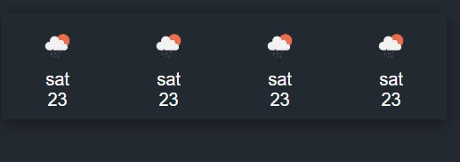 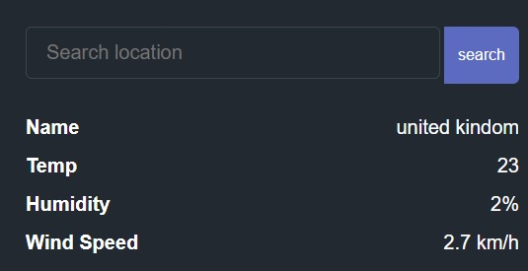

**2. Weather details for the search location**

**1. Future Weather Forecasting**

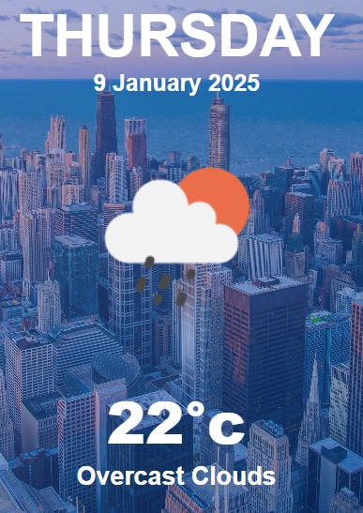 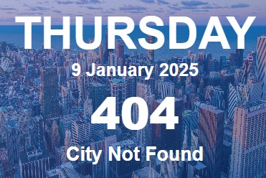

**4. error massage**

**3. current weather for the search location**

Conclusion

In conclusion, our weather forecasting app provides users with accurate, real-time weather updates, empowering them to plan their activities with confidence. By leveraging advanced meteorological data and user-friendly design, the app ensures accessibility and reliability for diverse audiences. Features such as severe weather alerts, daily and hourly forecasts, and personalized recommendations make it an indispensable tool in today's dynamic environment.

As we continue to innovate, the app will integrate even more advanced technologies, such as AI-driven prediction models and environmental insights, to further enhance user experience. Together, we aim to create a safer, more prepared, and environmentally conscious community.

# 6. References

 www.google.com

 https://www.codingninjas.com/

 https://www.woodlandhospital.in/

 https://www.w3schools.com/

 https://code.visualstudio.com/

 https://www.canva.com/

 https://openai.com/blog/chatgpt

 https://www.youtube.com/

 https://www.mayoclinic.org/

 https://html.com/